Shop Management System |  | [ PROJECT]  [ CS-76]  BCA  6th Semester
Pabitra Kumar Roy
Enrollment No:- 085483769

Contents
1. Introduction of the Project: 4
2. Objective of the Project: 6
3. Tools / Environment Used 7
IDE Used ( Visual Studio 2010): 7
Front End: 7
WPF (Windows Presentation Framework): 7
Programming Framework(.NET 4) : 8
Programming Language ( C#) : 8
4. Analysis of the Project: 10
3.1 Shop management system GUI 11
Billing Interface 12
Product Stock & Price Info browser 12
Supplier Details Browser 13
Employee Management Interface 13
Customer Management Interface 13
Sales Reporting Interface: 13
Login Interface 13
Register Interface 14
Video Surveillance Window 14
Web Interface 14
3.2 Shop management system Engine 15
Engine controller: 16
GUI Interactor: 16
Database Controller: 16
Video Surveillance Controller: 16
Customer Controller: 16
Supplier Controller: 17
Employee Controller: 17
Access Controller: 17
Data Entry Controller: 18
Product Controller: 18
Search Engine: 19
Billing Handler: 19
Reporting Handler: 19
Web Controller: 19
3.3 Shop management system Database 20
4. Hardware & Software Requirements for the application to run 20
4.1 Hardware Requirements 20
4.2 Software Requirements 20
5. Project Structure: 21
5.1 Project Estimation: 21
E-R Diagram: 23
DESIGN DOCUMENT: 25
6. Any Client/Industry: 36
7. Future Scope and Further enhancement of the project: 38

Introduction of the Project:
Shop management system is software for keeping computerized records of available products, pricing information, billing, available stocks, income details, employee info and transaction details. Shop management system can be used by the shop employees, shop owner, shop auditor as well as by the customers.
Shop Management System is the stand alone software required to manage any shop. It will provide an online interface to the owner & the auditors to check details about the shop online. It will also allow the customers to check product stock & pricing online and buy the product.
This software will make maintaining & keeping track of a shop fully computerized. It will make shop management more efficient and convenient
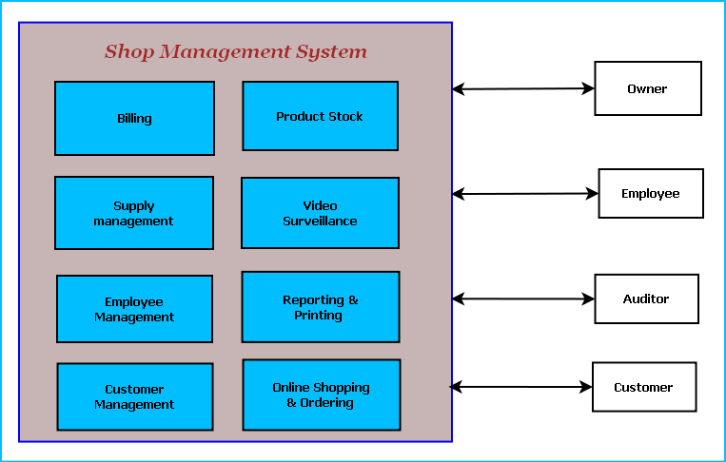
Figure: Overview of Shop Management System
The feature and user of the Shop management system are displayed in the diagram above.
The main features of this software are given below:
  - Bill preparation & printing.
  - Product stock & pricing information query.
  - Monthly / daily sales report
  - Shop Employee management.
  - Customer management.
  - Supply management & payment tracking.
  - Online shopping & ordering online.
  - Video Surveillance and Shop security management.

Objective of the Project:
The main objectives of the Shop management system project are given below:
- This software will help Shop owner to manage the shop more conveniently.
- This will make the customers life easy by providing various ways to purchase goods more efficiently and seamlessly.
- This will enable the shop owner to generate bills for customer.
- This will help shop owners to manage shop inventory.
- While developing this software we will learn the full life cycle of software development and also learn new technologies like .NET, C#, XML.

Tools / Environment Used
This software will follow Object Oriented Programming Paradigm and use below mentioned areas.

IDE Used ( Visual Studio 2010):

Microsoft Visual Studio is a powerful IDE that ensures quality code throughout the entire application lifecycle, from design to deployment. Whether we are developing applications for SharePoint, the web, Windows, Windows Phone, and beyond, Visual Studio is the ultimate all-in-one solution. Visual Studio includes a code editor supporting IntelliSense as well as code refactoring. The integrated debugger works both as a source-level debugger and a machine-level debugger. Other built-in tools include a forms designer for building GUI applications, web designer, class designer, and database schema designer. It accepts plug-ins that enhance the functionality at almost every level—including adding support for source-control systems (like Subversion and Visual SourceSafe) and adding new toolsets like editors and visual designers for domain-specific languages or toolsets for other aspects of the software development lifecycle (like the Team Foundation Server client: Team Explorer).

Front End:

WPF (Windows Presentation Framework):
Windows Presentation Foundation (WPF) provides developers with a unified programming model for building rich Windows smart client user experiences that incorporate UI, media, and documents. Windows Presentation Foundation (WPF) is a next-generation presentation system for building Windows client applications with visually stunning user experiences. With WPF, you can create a wide range of both standalone and browser-hosted applications. The core of WPF is a resolution-independent and vector-based rendering engine that is built to take advantage of modern graphics hardware. WPF extends the core with a comprehensive set of application-development features that include Extensible Application Markup Language (XAML), controls, data binding, layout, 2-D and 3-D graphics, animation, styles, templates, documents, media, text, and typography. WPF is included in the Microsoft .NET Framework, so you can build applications that incorporate other elements of the .NET Framework class library.

Programming Framework(.NET 4) :


The .NET 4 Framework is Microsoft's platform for building applications that have visually stunning user experiences, seamless and secure communication, and the ability to model a range of business processes. The .Net Framework consists of:
- Common Language Runtime – provides an abstraction layer over the operating system
- Base Class Libraries – pre-built code for common low-level programming tasks
- Development frameworks and technologies – reusable, customizable solutions for larger programming tasks.
The framework's Base Class Library provides user interface, data access, database connectivity, cryptography, web application development, numeric algorithms, and network communications. The class library is used by programmers, who combine it with their own code to produce applications.

Programming Language ( C#) :
C# is a type-safe, object-oriented language that is simple yet powerful, allowing programmers to build a breadth of applications. C# is a multi-paradigm programming language encompassing imperative, declarative, functional, generic, object-oriented(class-based), and component-oriented programming disciplines. It was developed by Microsoft within the .NET initiative and later approved as a standard by Ecma (ECMA-334) and ISO (ISO/IEC 23270). C# is one of the programming languages designed for the Common Language Infrastructure.
C# is intended to be a simple, modern, general-purpose, object-oriented programming language.

Front End/ GUI Tools: Visual Studio 2010, .NET 4, C#
Backend: MySQL
Internet Technologies: HTML, JavaScript, PHP, Google App Framework
Networking Technologies: TCP/IP
Wireless Technologies: Bluetooth
Operating Systems: Windows XP, Windows 7
Applications: ERP application, Database Management System.

Analysis of the Project:
Shop management system will provide a cost effective & efficient software solution for managing everything about shop. Different components of shop management system area are depicted below.
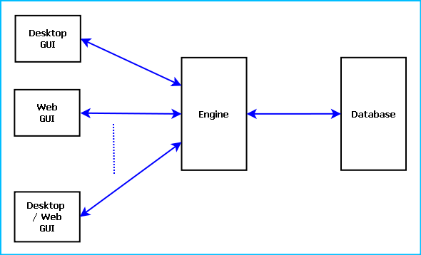
Figure: Components of Shop management system

Shop management system is divided into three main components. Such as:
- Shop management system GUI
- Shop management system Engine
- Shop management system Database

3.1 Shop management system GUI
Shop management system GUI will allow bill preparation, product information search and sales report generation. It is divided into ten modules. Such as:
- Billing Interface
- Product Stock & Price Info browser
- Supplier Details Browser
- Employee Management Interface
- Customer Management Interface
- Sales Reporting Interface
- Login Interface
- Register Interface
- Video Surveillance Window
- Web Interface
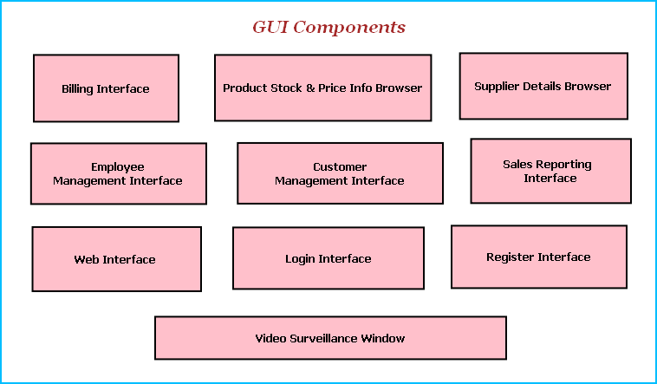
Figure: GUI Components

Billing Interface
Billing interface enables bill generation for customer purchase. Shop employees will scan the barcode of the product or manually enter the product id and quantity. Then the shop management system will search the product price and prepare the bill for printing. It will allow user to pay the bill by cash or credit/debit card.

Product Stock & Price Info browser
This interface will allow user to search any kind product of the shop and view price information and stock details.

Supplier Details Browser
This interface will display all the information about the suppliers of the shop. Materials taken from supplier, quantity, payments and customer feedback can be viewed from this interface. Employees can order new supply from here.

Employee Management Interface
This module will manage the employees responsible for shop operations. It will keep track of employee attendance, duty hours, customer support quality and feedbacks.

Customer Management Interface
This module will maintain information about Customer and purchase details. Shop management can maintain shopper’s card for customers. Using shopper’s card customers can avail special offers.

Sales Reporting Interface:
This module will display reports like monthly sales report, debit-credit, profit-loss and income tax payable. This module will be modified according to shop owner’s request.

Login Interface
Shop Management System can be used by variety of users like: Owner, employee, auditor and customer. So users need to login using user id, password & access type to distinguish between different kinds of users and to access their accessible features.

Register Interface
Users need to register for the first time to use the Shop management system in the future. It will generate user id, password & access right.

Video Surveillance Window
Video Surveillance window displays the video of the area where the security cameras are installed. It can record the video for a specified time limit.

Web Interface
Web interface allows accessing certain features from online. Users search for products and buy them through web interface. Shop owner views sales report from web interface and auditor reviews sales report through web interface.
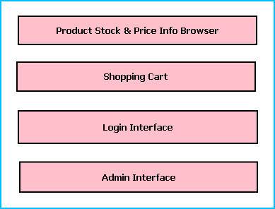
Figure: Web Interface Modules
- Product Stock & Price Info Browser: Users can browse for available products and view their pricing information from this web module.
- Shopping Cart: Users will be able to add the preferred items to their shopping cart and place a purchase order by paying the amount online. Customers also can order for home delivery or pay on receipt.
- Admin Interface: This interface allows shop owners and auditor to view reports about the shop.
- Login Interface: This interface will allow customer, auditor and owner to login and provide personal details required for shopping and delivery.

3.2 Shop management system Engine
Shop Management Engine controls the overall system. It provides logical and tactical solutions for managing the whole system. The Shop management system is divided into 14 divided modular components. Such as:
- Engine controller | - Employee Controller
- GUI Interactor | - Web Controller
- Database Controller | - Data Entry Controller
- Video Surveillance Controller | - Billing Handler
- Customer Controller | - Search Engine
- Supplier Controller | - Product Controller
- Access Controller | - Reporting Handler

Engine controller:
This controls the overall interaction between all the backend modules. It schedules the priority of the actions in case of overlapping.

GUI Interactor:
It interacts with the GUI and polls GUI calls. It exposes APIs and events for GUI to use. GUI Interactor helps Engine to maintain wrapper around the Engine modules so that the GUI can be ported to any other framework without much changes in Engine code.

Database Controller:
It controls the database interactions. It forms query to fetch information from the database. It also sends data to be saved in database for future use.

Video Surveillance Controller:
This module processes the images and videos taken while surveillance and exposes APIs for viewing and Playing back. It also archives the video and images to save space.

Customer Controller:
It keeps track of customer information. It has an algorithm for maintaining customer’s purchase history and rating the customer’s purchase quantity and preferences. Depending Customer controller data Shop management can offer special benefits to the users.

Supplier Controller:
It saves information about the material suppliers of shop. It validates the quantity supplied, quality of the products, payment history. Depending on the saved data it will decide preferred supplier for next order.

Employee Controller:
It controls the employee attendance, employee information and duty hours & duty locations. It can generate monthly reports on employee details to provide it to the management for performance evaluation.

Access Controller:
Access controller manages user login and features to be accessed by them. It will validate user’s login and block access & inform management if any access violation attempts happen.

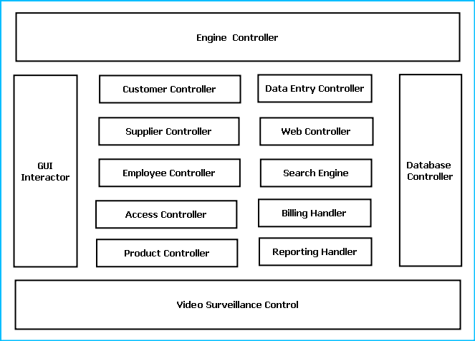
Figure: Components of Engine

Data Entry Controller:
It controls the data entered and passed to the engine. It validates the data depending on predefined inputs. If validation is failed it generates warning messages.

Product Controller:
This module will maintain the information about products. It will derive the figures about product selling trends, profit margin and quality of the product. It will save the information in database and retrieve them when required.

Search Engine:
Search engine enables rapid and efficient searching of data about customers, employees and suppliers. Search Engine prepares search indexes depending most accessed data. It improves the efficiency and performance of the software.

Billing Handler:
Billing Handler allows generating the bill for customer purchases. It will get the pricing information from the database depending on employee input about product type and quantity. It will add discounts, special offer and VAT amounts on the purchase amount and calculate the amount payable.

Reporting Handler:
Reporting Handler will enable the users with higher admin rights such as Owner, manager, auditor to view calculated report about shop’s different financial and operational aspects. It will expose a scripting interface so that users can write rules to generate reports.

Web Controller:
Web controller handles the interaction with web interface. Web interface will query for several data and web handler will search, calculate and provide the data. It will collate the purchase orders and assign to an employee to process it.

3.3 Shop management system Database
Shop management system will maintain a centralized database for storing information. We will design a RDBMS to manage the database and engine interaction. It will have optimized design and archive older data to save space and increase performance.

4. Hardware & Software Requirements for the application to run

4.1 Hardware Requirements
Computer that has a 1.6GHz or faster processor | Security Cameras
1 GB (32 Bit) or 2 GB (64 Bit) RAM | Barcode Reader
10 MB of available hard disk space | Bill Printing Machine
DVD-ROM Drive / USB Port | Webcam
Credit Card Swipe Machine

4.2 Software Requirements
Windows XP (x86) with Service Pack 3 / Windows Vista (x86 & x64) with Service Pack 2 / Windows 7 (x86 & x64)
Microsoft .NET 4.0

Project Structure:

5.1 Project Estimation:
Task Group | Task | Duration  ( Man-Days)
GUI | GUI design | 30 days
GUI | Billing Interface | 30 days
GUI | Product Stock & Price Info browser | 30 days
GUI | Supplier Details Browser | 30 days
GUI | Employee Management Interface | 30 days
GUI | Customer Management Interface | 30 days
GUI | Sales Reporting Interface | 30 days
GUI | Login Interface | 30 days
GUI | Register Interface | 30 days
GUI | Video Surveillance Window | 30 days
GUI | Web Interface | 30 days
Engine | Engine Design | 60 days
Engine | Engine controller | 60 days
Engine | GUI Interactor | 60 days
Engine | Database Controller | 60 days
Engine | Video Surveillance Controller | 60 days
Engine | Customer Controller | 60 days
Engine | Supplier Controller | 60 days
Engine | Access Controller | 60 days
Engine | Employee Controller | 60 days
Engine | Web Controller | 60 days
Engine | Data Entry Controller | 60 days
Engine | Billing Handler | 60 days
Engine | Search Engine | 60 days
Engine | Product Controller | 60 days
Engine | Reporting Handler | 60 days
Database | Database Design | 30 days
Database | Database Implementation | 30 days
Database | Optimization | 30 days
Integration | Application Integration | 20 days
Integration | Creating Installer | 20 days
Testing | Unit Testing | 20 days
Testing | Integration Testing | 20 days
Testing | Regression Testing | 20 days
Testing | System Testing | 20 days
Documentation | Synopsis | 20 days
Documentation | Design Document | 20 days
Documentation | Help Document | 20 days

E-R Diagram:

We will design a RDBMS for File Management System. The entities and their attributes are listed below. Attributes in Bold letter is the unique key.
Entities | Attributes
Customer | Customer Id, Name, Address , Contact Number
Shop management system | Shop Id , Name, Address
Employee | Employee Id, Name, Admin Right
Supplier | Member Id, Name, address, contact number, emergency contact number
Customer Preference | Preference Id, Type, Description
Product | Product id, stock, name, price

Relationship between Entities:
- Shop management system has Customers→ 1 : N
- Shop management system has Suppliers→ 1 : N
- Shop management system has Employees→ 1 : N
- Shop management system Sells Products → 1 : N
- Customers provide Preferences → M : N
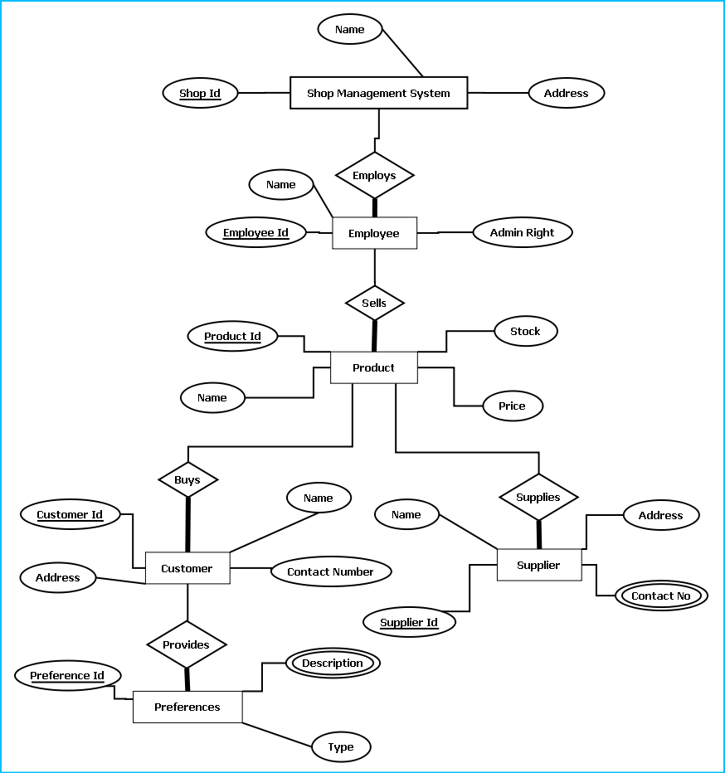
E-R Diagram of Shop management system

DESIGN DOCUMENT:
The user interface is developed using WPF..
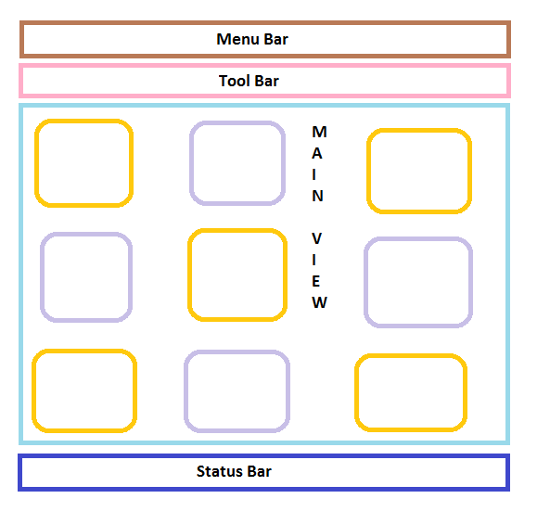
Menu bar contains the important features which can be accessed by shortcuts too. It is implemented using Menu control.
System.Windows.Controls.Menu
Namespace: System.Windows.Controls
Assembly: PresentationFramework (in PresentationFramework.dll)
Represents a Windows menu control that enables you to hierarchically organize elements associated with commands and event handlers.

Toolbar lists down the mostly used features. It is implemented using ToolBar control.
System.Windows.Controls.ToolBar
Namespace: System.Windows.Controls
Assembly: PresentationFramework (in PresentationFramework.dll)
Provides a container for a group of commands or controls.

Left navigation bar displays the tutorials available locally and online. This navigation bar is hide- able. It is implemented using the Expander control.
System.Windows.Controls.Expander
Namespace: System.Windows.Controls
Assembly: PresentationFramework (in PresentationFramework.dll)
Represents the control that displays a header that has a collapsible window that displays content.

The local contents are displayed in a TreeView control. And every contents are displayed in in a TreeViewItem.
System.Windows.Controls.TreeView
Namespace: System.Windows.Controls
Assembly: PresentationFramework (in PresentationFramework.dll)
Represents a control that displays hierarchical data in a tree structure that has items that can expand and collapse.

Online contents are displayed in a WebBrowser control. Users can select the content and purchase it from there.
System.Windows.Controls.WebBrowser
Namespace: System.Windows.Controls
Assembly: PresentationFramework (in PresentationFramework.dll)
Hosts and navigates between HTML documents. Enables interoperability between WPF managed code and HTML script.

Textpane displays the Texts. This is implemented using a TextBlock control.
System.Windows.Controls.TextBlock
Namespace: System.Windows.Controls
Assembly: PresentationFramework (in PresentationFramework.dll)
Provides a lightweight control for displaying small amounts of flow content.

Video and audio playing is implemented using MediaElement control.
System.Windows.Controls.MediaElement
Namespace: System.Windows.Controls
Assembly: PresentationFramework (in PresentationFramework.dll)
Represents a control that contains audio and/or video.

Images are displayed using Image control.
System.Windows.Controls.Image
Namespace: System.Windows.Controls
Assembly: PresentationFramework (in PresentationFramework.dll)
Represents a control that displays an image.

Drawing pane is implemented using InkCanvas control.
System.Windows.Controls.InkCanvas
Namespace: System.Windows.Controls
Assembly: PresentationFramework (in PresentationFramework.dll)
Defines an area that receives and displays ink strokes.

Statusbar displays the information about the application and the tutorial currently running. Its implemented using StatusBar Class.
System.Windows.Controls.Primitives.StatusBar
Namespace: System.Windows.Controls.Primitives
Assembly: PresentationFramework (in PresentationFramework.dll)
Represents a control that displays items and information in a horizontal bar in an application window.

Engine Design:
Reading & Writing XML:
In this application the tutorials are saved as XML file. The application will process the XML and play the tutorial. So we have implemented XML reader and writer logic. XML operations are done using .NET XML parser. Every XML element is represented as a XElement control.
System.Xml.Linq.XElement
Namespace: System.Xml.Linq
Assembly: System.Xml.Linq (in System.Xml.Linq.dll)
Represents an XML element.

It has a well designed Database in MSSQL to save all the information.
Installer:
We are Using Visual Studio Installer to package this software.
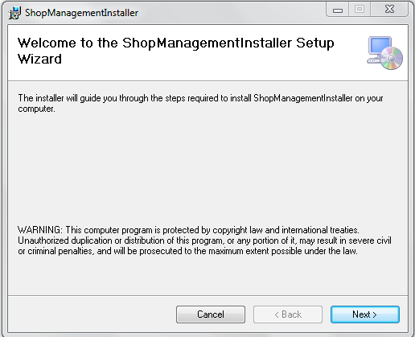
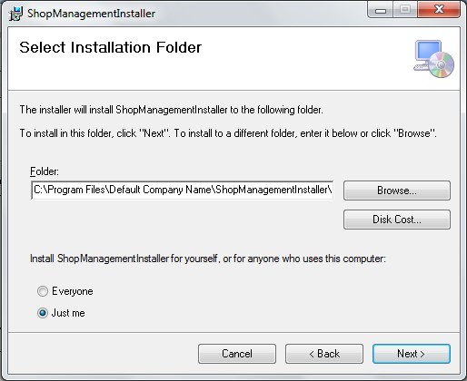
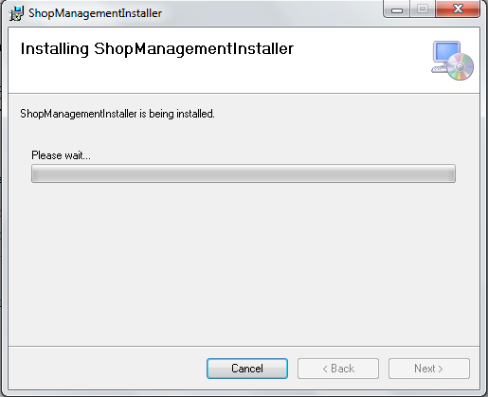

PROGRAMME CODE:
MainWindow.xaml
<Window x:Class="ShopManagementSystem.MainWindow"
xmlns="http://schemas.microsoft.com/winfx/2006/xaml/presentation"
xmlns:x="http://schemas.microsoft.com/winfx/2006/xaml"
Title="MainWindow" Height="350" Width="525" BorderBrush="#FFBA9999" Background="#FFCBB6B6">
<DockPanel LastChildFill="True">
<Menu DockPanel.Dock="Top">
<MenuItem Header="File">
<MenuItem Header="Employee Login"></MenuItem>
<MenuItem Header="New Connection"></MenuItem>
<MenuItem Header="Query"></MenuItem>
<MenuItem Header="Payment"></MenuItem>
<MenuItem Header="Inspection Order"></MenuItem>
<MenuItem Header="Estimate and Quotation"></MenuItem>
<MenuItem Header="Work Order"></MenuItem>
<MenuItem Header="Contractor Bill"></MenuItem>
<MenuItem Header="Close" Name="closeBtn" Click="closeBtn_Click"></MenuItem>
</MenuItem>
<MenuItem Header="View">

</MenuItem>

<MenuItem Header="Tools"></MenuItem>
<MenuItem Header="Help"></MenuItem>

</Menu>
<ToolBar DockPanel.Dock="Top">
<Label FontWeight="Bold">Employee:</Label>
<Label>Pabitra Kumar</Label>
<Separator></Separator>
<Label FontWeight="Bold">Access:</Label>
<Label>User</Label>
<Separator></Separator>
<Button>Options</Button>
<Separator></Separator>
<Button Name="VidBtn" Click="VidBtn_Click">Video Surveillance</Button>
<Separator></Separator>
<Button FontWeight="Bold">Log In</Button>
</ToolBar>
<StatusBar DockPanel.Dock="Bottom">
<Label>Time: 11.15 AM</Label>
<ProgressBar Width="100" Height="30"></ProgressBar>
<Label>Last Transaction Amount: 1000 INR</Label>

</StatusBar>
<UniformGrid Columns="3" DockPanel.Dock="Bottom">
<Button Margin="10" Name="loginBtn" Click="loginBtn_Click" Content="Employee Login"></Button>
<Button Margin="10" Content="New Bill"></Button>
<Button Margin="10" Content="Product Query"></Button>
<Button Margin="10" Content="Payment"></Button>
<Button Margin="10" Content="Purchase Order"></Button>
<Button Margin="10" Content="Estimate and Quotation"></Button>
<Button Margin="10" >Search</Button>
<Button Margin="10" >Sales Report</Button>
<Button Name="cusBtn" Click="cusBtn_Click" Margin="10" >Customer Browser</Button>

</UniformGrid>
</DockPanel>
</Window>

MainWindow.xaml.cs
using System;
using System.Collections.Generic;
using System.Linq;
using System.Text;
using System.Windows;
using System.Windows.Controls;
using System.Windows.Data;
using System.Windows.Documents;
using System.Windows.Input;
using System.Windows.Media;
using System.Windows.Media.Imaging;
using System.Windows.Navigation;
using System.Windows.Shapes;

namespace ShopManagementSystem
{
/// <summary>
/// Interaction logic for MainWindow.xaml
/// </summary>
public partial class MainWindow : Window
{
public MainWindow()
{
InitializeComponent();
}

private void closeBtn_Click(object sender, RoutedEventArgs e)
{
this.Close();
}

private void loginBtn_Click(object sender, RoutedEventArgs e)
{
LoginWindow lw = new LoginWindow();
lw.ShowDialog();
}

private void VidBtn_Click(object sender, RoutedEventArgs e)
{
VideoSurveillance vsw = new VideoSurveillance();
vsw.ShowDialog();
}

private void cusBtn_Click(object sender, RoutedEventArgs e)
{
Customers cus = new Customers();
cus.ShowDialog();
}
}
}

<Window x:Class="CyberCafeController.AccessRightWindow"
xmlns="http://schemas.microsoft.com/winfx/2006/xaml/presentation"
xmlns:x="http://schemas.microsoft.com/winfx/2006/xaml"
Title="Access Right Window" Height="200" Width="346">
<UniformGrid Rows="3">
<Label VerticalContentAlignment="Center">Machine Name</Label>
<ComboBox Margin="15" SelectedIndex="2">
<ComboBoxItem>1</ComboBoxItem>
<ComboBoxItem>2</ComboBoxItem>
<ComboBoxItem>3</ComboBoxItem>
<ComboBoxItem>4</ComboBoxItem>
<ComboBoxItem>5</ComboBoxItem>
<ComboBoxItem>6</ComboBoxItem>
<ComboBoxItem>7</ComboBoxItem>
</ComboBox>
<Label VerticalContentAlignment="Center">Access Type</Label>
<ComboBox Margin="15" SelectedIndex="2">
<ComboBoxItem>Install software</ComboBoxItem>
<ComboBoxItem>Write CD</ComboBoxItem>
<ComboBoxItem>Use Pendrive</ComboBoxItem>
<ComboBoxItem>Recharge</ComboBoxItem>

</ComboBox>
<Button Margin="10">Cancel</Button>
<Button Margin="10">Permit</Button>
</UniformGrid>
</Window>

BillingWindow.xaml
<Window x:Class="CyberCafeController.BillingWindow"
xmlns="http://schemas.microsoft.com/winfx/2006/xaml/presentation"
xmlns:x="http://schemas.microsoft.com/winfx/2006/xaml"
Title="Billing Window" Height="340" Width="311">
<UniformGrid Columns="2">
<Label VerticalContentAlignment="Center">Machine Name</Label>
<ComboBox Margin="15" SelectedIndex="2">
<ComboBoxItem>1</ComboBoxItem>
<ComboBoxItem>2</ComboBoxItem>
<ComboBoxItem>3</ComboBoxItem>
<ComboBoxItem>4</ComboBoxItem>
<ComboBoxItem>5</ComboBoxItem>
<ComboBoxItem>6</ComboBoxItem>
<ComboBoxItem>7</ComboBoxItem>
</ComboBox>
<Button Margin="10">Get Info</Button>
<Label></Label>
<Label>Time Spent</Label>
<Label>45 min</Label>

<Label>Balance Available </Label>
<Label>Rs 30</Label>
<Label VerticalContentAlignment="Center">Recharge Amount</Label>
<TextBox Margin="10"></TextBox>

<Button Margin="10">Close</Button>
<Button Margin="10">Recharge</Button>
</UniformGrid>
</Window>

Customers.xaml
<Window x:Class="CyberCafeController.Customers"
xmlns="http://schemas.microsoft.com/winfx/2006/xaml/presentation"
xmlns:x="http://schemas.microsoft.com/winfx/2006/xaml"
Title="Customers" Height="411" Width="733">
<Grid Height="350" Width="684">
<Button Content="View Info" Height="23" HorizontalAlignment="Left" Margin="414,39,0,0" Name="button1" VerticalAlignment="Top" Width="75" />
<Label Content="Existing Customer" Height="28" HorizontalAlignment="Left" Margin="37,39,0,0" Name="label1" VerticalAlignment="Top" />
<ComboBox Height="23" HorizontalAlignment="Left" Margin="181,39,0,0" Name="comboBox1" VerticalAlignment="Top" Width="175" />
<Label Content="Name" Height="28" HorizontalAlignment="Left" Margin="37,102,0,0" Name="label2" VerticalAlignment="Top" Width="78" />
<TextBox Height="23" HorizontalAlignment="Left" Margin="181,102,0,0" Name="textBox1" VerticalAlignment="Top" Width="308" />
<Label Content="Id Card No:" Height="28" HorizontalAlignment="Left" Margin="37,163,0,0" Name="label3" VerticalAlignment="Top" />
<TextBox Height="23" HorizontalAlignment="Left" Margin="181,165,0,0" Name="textBox2" VerticalAlignment="Top" Width="308" />
<Label Content="Balance" Height="28" HorizontalAlignment="Left" Margin="37,241,0,0" Name="label4" VerticalAlignment="Top" Width="78" />
<TextBox Height="23" HorizontalAlignment="Left" Margin="181,246,0,0" Name="textBox3" VerticalAlignment="Top" Width="308" />
<Image Height="188" HorizontalAlignment="Left" Margin="516,41,0,0" Name="image1" Stretch="Fill" VerticalAlignment="Top" Width="148" />
<Button Content="Change Photo" Height="23" HorizontalAlignment="Left" Margin="516,245,0,0" Name="button2" VerticalAlignment="Top" Width="148" />
<Button Content="Update" Height="23" HorizontalAlignment="Left" Margin="405,310,0,0" Name="button3" VerticalAlignment="Top" Width="178" />
<Button Content="Cancel" Height="23" HorizontalAlignment="Left" Margin="113,310,0,0" Name="button4" VerticalAlignment="Top" Width="178" />
</Grid>
</Window>

LoginWindow.xaml
<Window x:Class="CyberCafeController.LoginWindow"
xmlns="http://schemas.microsoft.com/winfx/2006/xaml/presentation"
xmlns:x="http://schemas.microsoft.com/winfx/2006/xaml"
Title="Login Window" Height="211" Width="381">
<UniformGrid Rows="3">
<Label>User Name</Label>
<TextBox Margin="15"></TextBox>
<Label>Password</Label>
<TextBox Margin="15"></TextBox>
<Button Margin="10">Cancel</Button>
<Button Margin="10">Login</Button>
</UniformGrid>
</Window>

Products.xaml
<Window x:Class="CyberCafeController.Products"
xmlns="http://schemas.microsoft.com/winfx/2006/xaml/presentation"
xmlns:x="http://schemas.microsoft.com/winfx/2006/xaml"
Title="Products" Height="300" Width="300">
<UniformGrid Columns="2">
<Label VerticalAlignment="Center">Select Product</Label>
<ComboBox VerticalAlignment="Center" Margin="15" SelectedIndex="2">
<ComboBoxItem>CD</ComboBoxItem>
<ComboBoxItem>DVD</ComboBoxItem>
<ComboBoxItem>Paper</ComboBoxItem>
<ComboBoxItem>Headphone</ComboBoxItem>
<ComboBoxItem>Mouse</ComboBoxItem>
<ComboBoxItem>Pendrive</ComboBoxItem>
<ComboBoxItem>Other</ComboBoxItem>
</ComboBox>
<Label></Label>
<Button Margin="10">Get Info</Button>

<Label>Price</Label>
<Label>1.5 Rs</Label>
<Label>Stock</Label>
<Label>1000</Label>
<Button Margin="10">Close</Button>
<Button Margin="10">Purchase</Button>

</UniformGrid>
</Window>
VideoSurveillance.xaml
<Window x:Class="CyberCafeController.VideoSurveillance"
xmlns="http://schemas.microsoft.com/winfx/2006/xaml/presentation"
xmlns:x="http://schemas.microsoft.com/winfx/2006/xaml"
Title="VideoSurveillance" Height="307" Width="339">
<Grid Height="270">
<Grid.RowDefinitions>
<RowDefinition Height="226*" />
<RowDefinition Height="36*" />
</Grid.RowDefinitions>
<MediaElement x:Name="MediaEL" Grid.RowSpan="1" LoadedBehavior="Manual" />
<StackPanel Orientation="Horizontal" Grid.Row="1" HorizontalAlignment="Center" Margin="8,0,8,5" Width="301">
<Button x:Name="btnRec" Content="Record" Click="btnRec_Click"
Width="50" Height="25"/>
<Button x:Name="btnPlay" Content="Play" Click="btnPlay_Click"
Width="50" Height="25"/>
<Button x:Name="btnStop" Content="Stop" Click="btnStop_Click"
Width="50" Height="25"/>
<Button x:Name="btnMoveBackward" Content="Back" Click="btnMoveBackward_Click"
Width="50" Height="25"/>
<Button x:Name="btnMoveForward" Content="Forward" Click="btnMoveForward_Click"
Width="50" Height="25"/>
<Button x:Name="btnOpen" Content="Open" Click="btnOpen_Click"
Width="50" Height="25"/>
</StackPanel>
</Grid>
</Window>
VideoSurveillance.xaml.cs
using System;
using System.Collections.Generic;
using System.Linq;
using System.Text;
using System.Windows;
using System.Windows.Controls;
using System.Windows.Data;
using System.Windows.Documents;
using System.Windows.Input;
using System.Windows.Media;
using System.Windows.Media.Imaging;
using System.Windows.Shapes;

namespace CyberCafeController
{
/// <summary>
/// Interaction logic for VideoSurveillance.xaml
/// </summary>
public partial class VideoSurveillance : Window
{
public VideoSurveillance()
{
InitializeComponent();
IsPlaying(false);
}

private void btnRec_Click(object sender, RoutedEventArgs e)
{

}
#region IsPlaying(bool)
private void IsPlaying(bool bValue)
{
btnStop.IsEnabled = bValue;
btnMoveBackward.IsEnabled = bValue;
btnMoveForward.IsEnabled = bValue;
btnPlay.IsEnabled = bValue;
}
#endregion

#region Play and Pause
private void btnPlay_Click(object sender, RoutedEventArgs e)
{
IsPlaying(true);
if (btnPlay.Content.ToString() == "Play")
{
MediaEL.Play();
btnPlay.Content = "Pause";
}
else
{
MediaEL.Pause();
btnPlay.Content = "Play";
}
}
#endregion

#region Stop
private void btnStop_Click(object sender, RoutedEventArgs e)
{
MediaEL.Stop();
btnPlay.Content = "Play";
IsPlaying(false);
btnPlay.IsEnabled = true;
}
#endregion

#region Back and Forward
private void btnMoveForward_Click(object sender, RoutedEventArgs e)
{
MediaEL.Position = MediaEL.Position + TimeSpan.FromSeconds(10);
}

private void btnMoveBackward_Click(object sender, RoutedEventArgs e)
{
MediaEL.Position = MediaEL.Position - TimeSpan.FromSeconds(10);
}
#endregion

#region Open Media
private void btnOpen_Click(object sender, RoutedEventArgs e)
{
Microsoft.Win32.OpenFileDialog ofd = new Microsoft.Win32.OpenFileDialog();
ofd.Filter = "Video Files (*.wmv)|*.wmv";
if (ofd.ShowDialog() == true)
{
MediaEL.Source = new Uri(ofd.FileName);
btnPlay.IsEnabled = true;
}
}
#endregion
}
}

Algorithm for Database Connection:
Step1: Create connection
try
{
string dbConnectionString = "Data Source=9.126.164.183;Initial Catalog=
BTT_MESSAGE_INTEGRATION_Dave;User ID=wtrkplusdev;Password=wtrkplus0123;";
SqlConnection connection = new SqlConnection(dbConnectionString);
connection.Open();
} catch (SqlException sqlException)
{
// message
}
step2: Create a stored procedure command
SqlCommand sqlCommand = new SqlCommand(commandName, connection);
sqlCommand.CommandType = System.Data.CommandType.StoredProcedure;
sqlCommand.Transaction = transaction;
Step3: provide necessary input and output params to the sql command
SqlParameter paymentScheduleIDParam
= new SqlParameter(PARAM_PAYMENT_SCHEDULE_ID, paymentScheduleID);
paymentScheduleIDParam.SqlDbType = SqlDbType.Int;
paymentScheduleIDParam.Direction = ParameterDirection.Input;
sqlCommand.Parameters.Add(paymentScheduleIDParam);
Step4: Execute the command to read a value
SqlDataReader sqlReader = sqlCommand.ExecuteReader();
OR Execute a command to insert a value

int rows = sqlCommand.ExecuteNonQuery();
Step5: For read operation create business objects from sqlreader by writing DataMapper functions
//Add data from data reader to the business object list
while (sqlDataReader.Read())
{
if (!Convert.IsDBNull(sqlDataReader["PaymentDate"]))
{
lastPaymentDate = Convert.ToDateTime(sqlDataReader["PaymentDate"]);
}
}

TESTING:

UNIT TESTCASES:
Test case Id | Description | Prerequisite | Steps to produce
CCMS_UT_001 | Load a tutorial | Valid tutorial and a software | - Launch the software  - double click on left navigation pan
CES_UT_002 | Display Text | Valid tutorial and a software | - Launch the software  - double click on left navigation pan
CES_UT_003 | Display Image | Valid tutorial with Image and a software | - Launch the software  - double click on left navigation pan
CES_UT_004 | Display Video | Valid tutorial with video and a software | - Launch the software  - click on video tab
CES_UT_005 | Video Play | Valid tutorial with video and a software | - Launch the software  - click on video tab
CES_UT_006 | Video Pause | Valid tutorial and a software | - Launch the software  - click once
CES_UT_007 | Video Stop | Valid tutorial and a software | - Launch the software  - click on stop button
CES_UT_008 | Video Fast Forward | Valid tutorial and a software | - Launch the software  - click on fast forward button
CES_UT_009 | Video Rewind | Valid tutorial and a software | - Launch the software  - click on back button
CES_UT_010 | Video Open | Valid tutorial and a software | - Launch the software  - click on open button
CES_UT_011 | Display Online Store | Valid tutorial and a software | - Launch the software  - click on Buy button (Online Store Navigation pan)
CES_UT_013 | Go to Online Store Link | Valid tutorial and a software | - Launch the software  - click on buy button left navigation pan
CES_UT_014 | Sound On/Off | Valid tutorial and a software | - Launch the software  - click on sound on/off button
CES_UT_015 | Local tutorial Display | Valid tutorial and a software | - Launch the software  - click on open button to browse the saved tutorials.
CES_UT_016 | Menu items functionality | Valid tutorial and a software | - Launch the software  - click on menubar
CES_UT_017 | Toolbar item functionality | Valid tutorial and a software | - Launch the software  - click on toolbar buttons

INTEGRATION TESTCASES:
Test case Id | Description | Prerequisite | Steps to produce
CES_IT_001 | Completely Run a Tutorial | Installed software and a valid and tutorial | - Launch the software  - double click on left navigation pan
CES_IT_002 | Run a Saved Tutorial | Installed software and a valid and tutorial | - Launch the software  - double click on left navigation pan and click on open button to browse the saved tutorial
CES_IT_003 | Run a downloaded Tutorial | Installed software and a valid and tutorial and an internet connection | - Launch the software  - Download a tutorial from online store.
CES_IT_004 | Check the installer | Installed software | - Launch the software  - double click on icon

SYSTEM TESTCASES:
Test case Id | Description | Prerequisite | Steps to produce
CES_ST_001 | Install the software | CES installer,.net frame work | Double click on the setup file
CES_ST_002 | Launch the software from desktop shortcut | CES installed ,.net frame work | Double click on the CES icon
CES_ST_003 | Launch the software from program menus | CES installed,.net frame work | Navigate from start and click on CES icon
CES_ST_004 | Run a tutorial | CES installed,.net frame work | - Launch the software  - double click on left navigation pan and click on open button to browse the saved tutorial
CES_ST_005 | Close the Software | CES installed,.net frame work , launched software | Press alt+f4 or click on close button
CES_ST_006 | Uninstall the Software | CES installed,.net frame work | Open control panel and uninstall the program.
CES_ST_007 | Download a Tutorial | CES installed,.net frame work,valid tutorial | - Launch the software  - Download a tutorial from online store.
CES_ST_008 | Run a Video tutorial | CES installed,.net frame work, valid tutorial with video | - Launch the software  - click on open button
CES_ST_009 | Run a Image Tutorial | CES installed,.net frame work, valid tutorial with image | - Launch the software  - click on open button

UNIT TEST RESULT:
UNIT TESTID | Expected Result | Actual Result | Comment | Status
CES_UT_001 | Load a tutorial | Load a tutorial | NA | PASS
CES_UT_002 | Display Text | Display Text | NA | PASS
CES_UT_003 | Display Image | Display Image | NA | PASS
CES_UT_004 | Display Video | Display Video | NA | PASS
CES_UT_005 | Video Play | Video Play | NA | PASS
CES_UT_006 | Video Pause | Video Pause | NA | PASS
CES_UT_007 | Video Stop | Video Stop | NA | PASS
CES_UT_008 | Video Fast Forward | Video Fast Forward | NA | PASS
CES_UT_009 | Video Rewind | Video Rewind | NA | PASS
CES_UT_010 | Video Open | Video Open | NA | PASS
CES_UT_011 | Display Online Store | Display Online Store | NA | PASS
CES_UT_013 | Go to Online Store Link | Go to Online Store Link | NA | PASS
CES_UT_014 | Sound On/Off | Sound On/Off | NA | PASS
CES_UT_015 | Local tutorial Display | Local tutorial Display | NA | PASS
CES_UT_016 | Menu items functionality | Menu items functionality | NA | PASS

INTEGRATION TEST RESULT:
Test case Id | Expected Result | Actual Result | Comment | Status
CES_IT_001 | Completely Run a Tutorial | Completely Run a Tutorial | NA | PASS
CES_IT_002 | Run a Saved Tutorial | Run a Saved Tutorial | NA | PASS
CES_IT_003 | Run a downloaded Tutorial | Run a downloaded Tutorial | NA | PASS
CES_IT_004 | Check the installer | Check the installer | NA | PASS

SYSTEM TEST RESULT:
Test case Id | Expected Result | Actual Result | Comment | Status
CES_ST_001 | Install the software | Install the software | NA | PASS
CES_ST_002 | Launch the software from desktop shortcut | Launch the software from desktop shortcut | NA | PASS
CES_ST_003 | Launch the software from program menus | Launch the software from program menus | NA | PASS
CES_ST_004 | Run a tutorial | Run a tutorial | NA | PASS
CES_ST_005 | Uninstall the Software | Uninstall the Software | NA | PASS
CES_ST_006 | Download a Tutorial | Download a Tutorial | NA | PASS
CES_ST_007 | Run a Video tutorial | Run a Video tutorial | NA | PASS
CES_ST_008 | Run a Image Tutorial | Run a Image Tutorial | NA | PASS

Input Output Screen

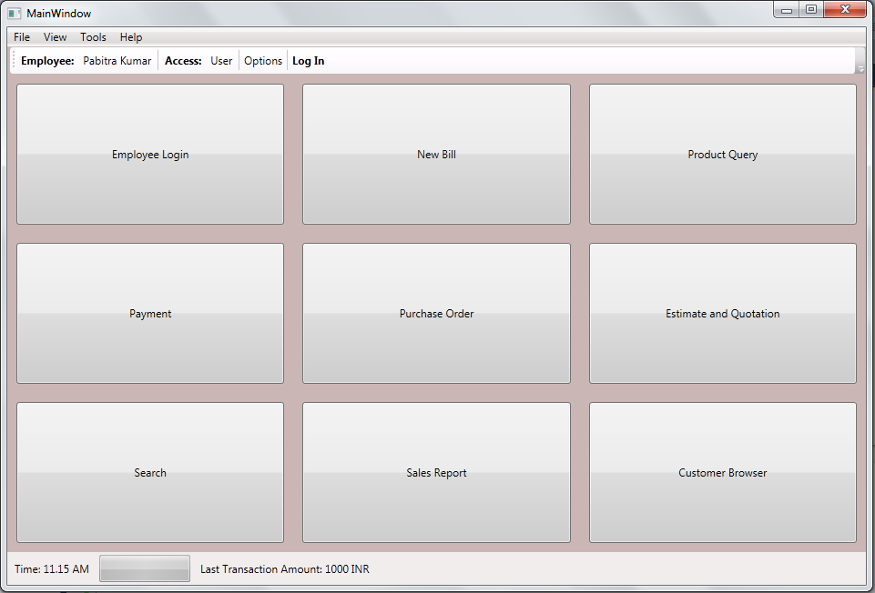

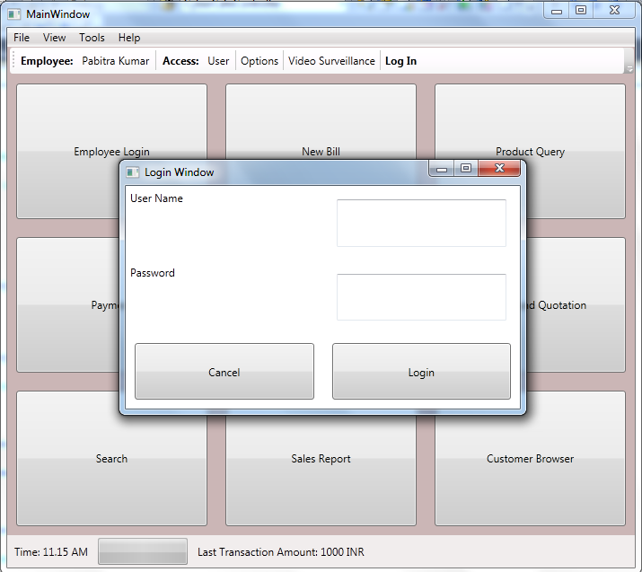

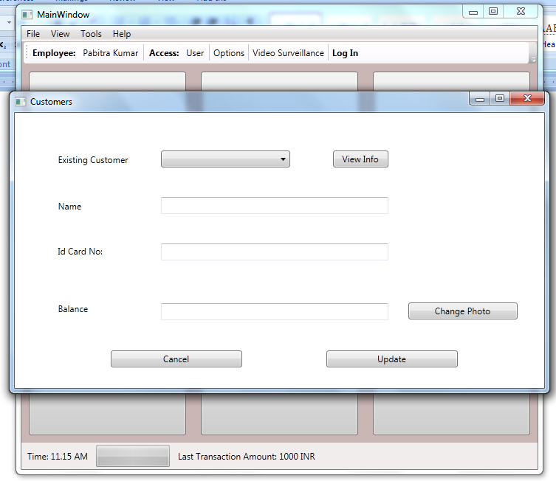

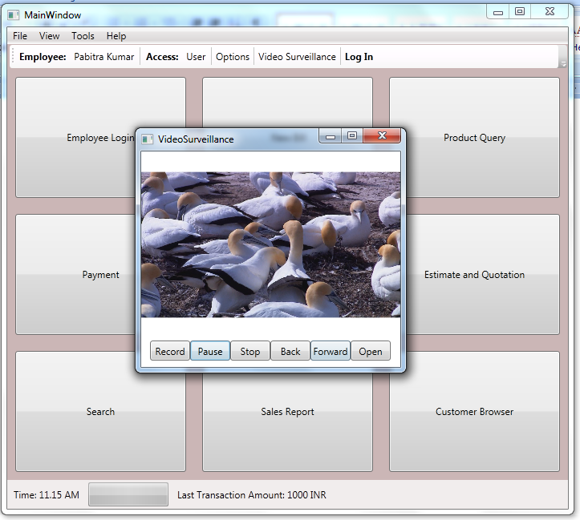

Any Client/Industry:

E-Komfort Zone
Bamangachi Station Road,
P.O: Bamangachi, P.S: Barasat,
Dist: North 24 Pgs
West Bengal- 743706

Future Scope and Further enhancement of the project:

    - To sink with multiple branch of a shop with a centralized database.
    - To support UNIX / Linux, MAC OSX Operating systems.

-
----------------------------- Thank You-------------------------

